Future Sales Prediction using Machine Learning
Aim
To implement a Future Sales Prediction model using Linear Regression in Python and predict future sales based on previous sales data.

Apparatus Required
- Google Colab / Jupyter Notebook
- Python 3
- Libraries:
  - NumPy
  - Pandas
  - Scikit-learn (sklearn)

Theory
Future Sales Prediction is a supervised machine learning regression problem used to estimate future sales from historical sales data. It helps businesses plan inventory, marketing, and production.
In this experiment, Linear Regression is used to learn the relationship between time (months) and sales, and predict future sales values.
Advantages:
- Simple and easy to implement.
- Fast training and prediction.
- Suitable for continuous value prediction.
Disadvantages:
- Assumes a linear relationship.
- Less accurate for highly non-linear sales trends.

Algorithm
- Import the required libraries.
- Create a sample sales dataset.
- Split the dataset into training and testing sets.
- Train the Linear Regression model.
- Predict future sales.
- Calculate the Mean Squared Error (MSE) and R² Score.
- Display the predicted sales values.

Code (Google Colab)
import pandas as pd
from sklearn.model_selection import train_test_split
from sklearn.linear_model import LinearRegression
from sklearn.metrics import mean_squared_error, r2_score

# Sample Sales Dataset
data = {
'Month': [1,2,3,4,5,6,7,8,9,10],
'Sales': [200,220,250,270,300,320,340,360,390,420]
}

df = pd.DataFrame(data)

# Features and Target
X = df[['Month']]
y = df['Sales']

# Split Dataset
X_train, X_test, y_train, y_test = train_test_split(
X, y, test_size=0.2, random_state=42
)

# Train Linear Regression Model
model = LinearRegression()
model.fit(X_train, y_train)

# Predict Test Data
y_pred = model.predict(X_test)

# Predict Future Sales (Months 11 and 12)
future_months = pd.DataFrame({'Month': [11, 12]})
future_sales = model.predict(future_months)

# Results
print("Actual Sales:")
print(y_test.values)

print("\nPredicted Sales:")
print(y_pred)

print("\nFuture Sales Prediction:")
for month, sale in zip(future_months['Month'], future_sales):
print(f"Month {month}: {sale:.2f}")

print("\nMean Squared Error (MSE):")
print(mean_squared_error(y_test, y_pred))

print("\nR2 Score:")
print(r2_score(y_test, y_pred))

Sample Output
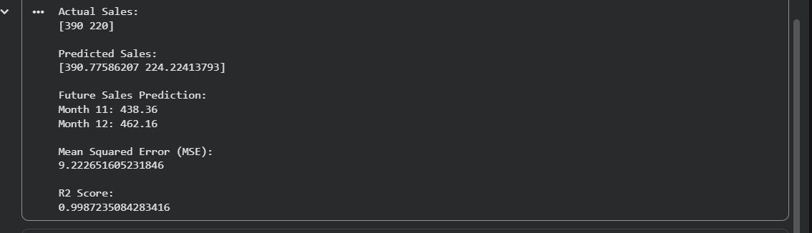
Result
The Future Sales Prediction model was successfully implemented using the Linear Regression algorithm in Python. The model predicted future sales based on historical sales data, and its performance was evaluated using the Mean Squared Error (MSE) and R² Score.

